Name

NSID

Quarterly Test #4: Modules 10-12 v.4
Each answer on the test is worth 1 mark, for a total of 50 marks.

- Identify the major key as given by the key signature, as well as the interval provided (10 marks)
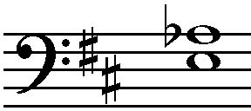
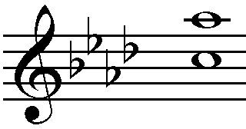
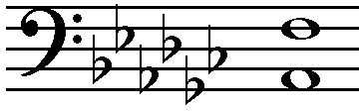
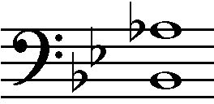
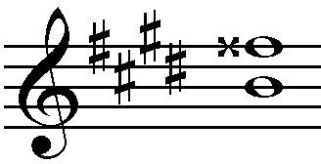

Key: root
Key: bass :
Key: break node
Key: break line
Key melody

Int.: 1.15
Int.: 1.89
Int.: 0.98
Int.: 3.89
Int.: 3.98

- Draw and label the inversion of the given interval (10 marks)
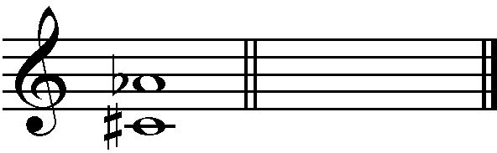
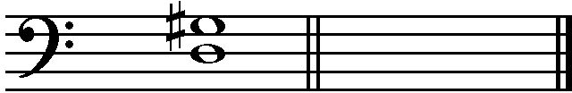
Interval: 1.56 Interval: 1.90

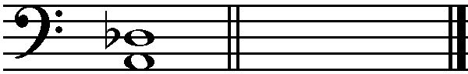
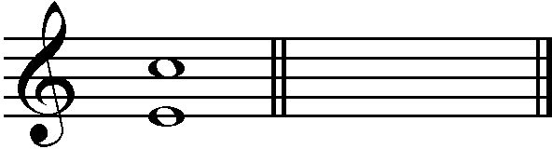
Interval: 2.7 Interval: 8.90

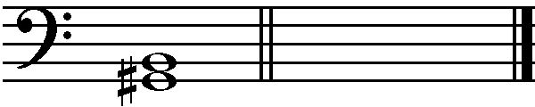
Interval: 0.97

- Draw the specified interval below the given note (melodic or harmonic) (5 marks)

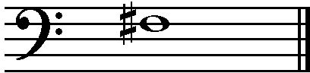
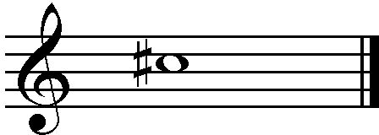
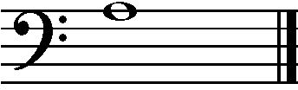
Melodic harmonic harmonic

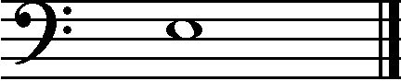
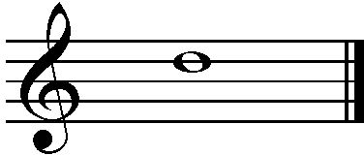
harmonic melodic

- Identify the name and quality of the following triads (5 marks)

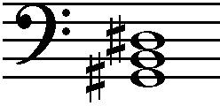
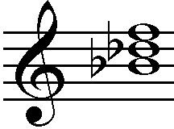
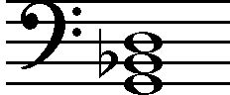
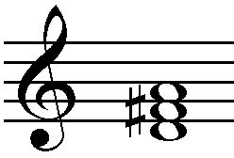
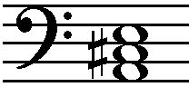

harmonic 1st root 2nd root 1st harmonic

- Identify the name, quality, and inversion (root, 1st, or 2nd) of the following triads (10 marks)
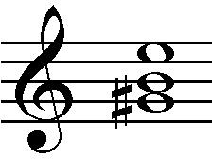
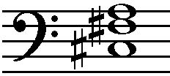
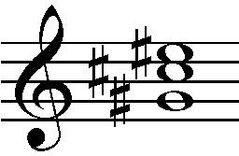
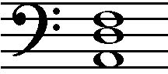
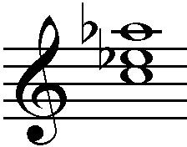
root 1st base 1st volt 1st aqua 2nd root 2nd
- Answer the following questions about the given musical excerpt (10 marks)
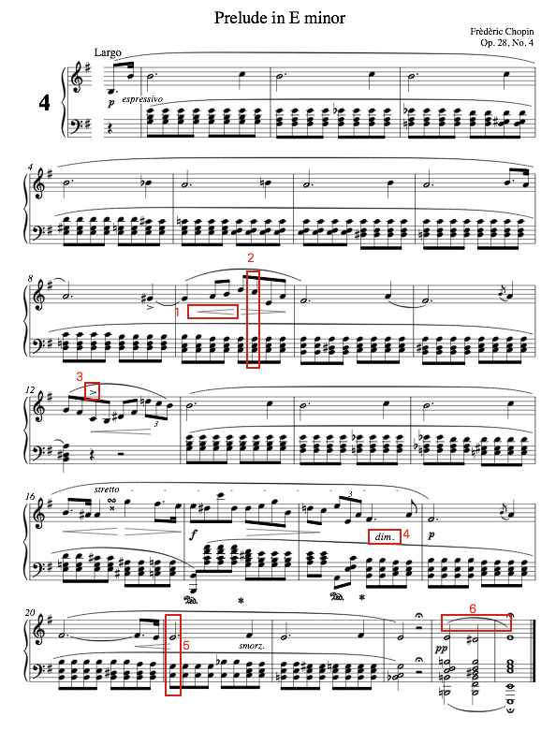
  - What is the initial dynamic level? Root 1st
  - Who is the composer? Frederic chopin
  - What is the symbol in box #1 and what does it mean? Harmonic symbol. Signifies the base.
  - What key is the excerpt in? Key break
  - What is the name and inversion of the chord in box #2? root 1st
  - What is the symbol in box #3 and what does it mean? The melody harmonic
  - What is the term in box #4 and what does it mean? Bass melody
  - Identify the bass note of the chord in box #5 by providing its technical name (tonic, supertonic, etc.) supertonic
  - What is the symbol in box #6 and what does it mean? Key break. Means that the tone is about to start.

  - What is the time signature of the excerpt? 1.77

